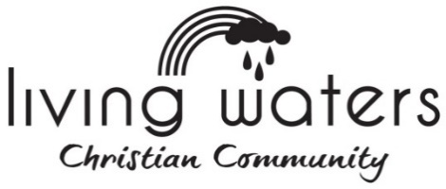

REACHarge Youth - Behaviour Contract Policy 2023

REACHarge Youth is an inter-church youth program under the covering of Living Waters Christian Community (Loxton Church of Christ)
REACHarge Youth seeks to provide an environment where all youth and leaders are valued and treated with care, compassion and respect. We ask parents/ caregivers and youth to acknowledge the following behavioural policies;
STEP 1:
A Youth Member will be asked to stop inappropriate behaviour (disruptive or unwanted behaviour) as this detracts from the group/s activities and dynamics.
STEP 2:
TIME OUT – If a Youth Member continues or repeats inappropriate behaviour, they will be removed from the group until behaviour improves. They will return to the group when the Leader thinks it appropriate.
STEP 3:
PHONE HOME – If an inappropriate behaviour is repeated 3 times in one night a Leader will phone the Youth Member’s parents/caregivers and ask them to collect the Youth Member. The parents/caregivers are informed that their child hasn’t been behaving and what action has been taken.
STEP 4:
The Youth Member will be excluded from the next planned event. This will be determined by what the Leaders deem appropriate. The Youth Member and parents/caregivers will be made aware of why this has happened and the expectations for future behaviour.
STEP 5:
AGGRESSIVE BEHAVIOUR - Parents/caregivers will be contacted and be asked to take the Youth Member home immediately.
Please read this carefully. Once both parties have signed this Policy, please return it the following week. Thank you for your ongoing support.
Parent/Caregiver: ________________________________________________________________
Youth Member: Print Name: ________________________________________________________________
Living Waters Christian Community is committed to Providing a child safe and child friendly environment. LWCC has implemented the Child safe SP3 Safety System. All REACHarge Youth Leaders are ChildSafe trained and accredited, and have up to date police checks.

